A244-Afr-Egy-Ushabti-New Kingdom-19th Dynasty, 1291 – 1278 BCE-Seti I

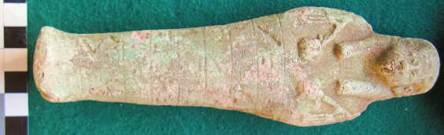

Fig. 1. Ushabti-New Kingdom-19th Dynasty, 1291 – 1278 BCE-Seti I

**Case No.: 2**

**Formal Label:** Ushabti-New Kingdom-19th Dynasty, 1291 – 1278 BCE-Seti I

**Display Description: This** Ushabti holds two hoes by which it is dated to the end 18th dynasty-end 25th dynasty. It has eight registers of hieroglyphs. There is no false beard.

**Accession Number: A 244**

**LC Classification:** DT62

**Date or Time Horizon:** 1291-1278 BCE

**Geographical Area:** Valley of the Kings in Thebes

**Date or Time Horizon:** New Kingdom-19th Dynasty, 1291 – 1278 BCE

**Geographical Area: Luxor, Egypt-Valley of the Kings, Seti I, Tomb KV17**

**Map, GPS Coordinates:** [25°44′23.3″N 32°36′06.8″E](https://tools.wmflabs.org/geohack/geohack.php?pagename=KV17&params=25_44_23.3_N_32_36_06.8_E_type:landmark_region:EG)

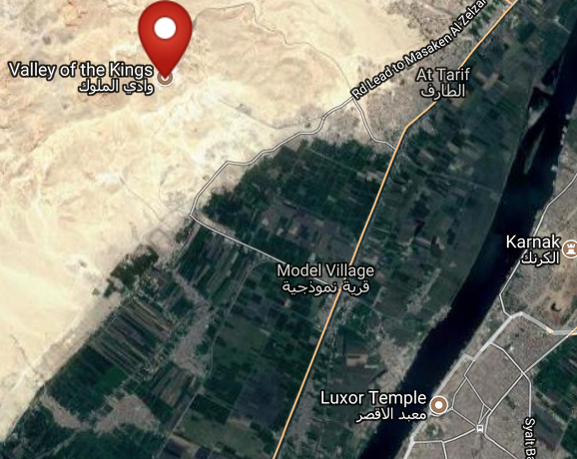 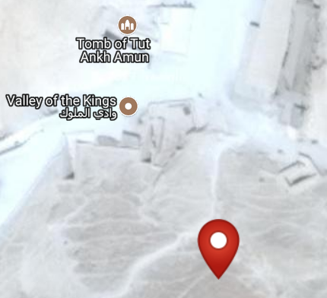

Figs. 2-3. Maps of KV17 from http://latitude.to/lat/25.73972/lng/32.60167

**Cultural Affiliation:** New Kingdom

**Medium:** blue faience

**Dimensions: H 181.40 mm; 7.14 in  
Weight: 152 g; 5.25 oz**

**Provenance: unknown**

**Condition: original**

**Discussion:** When Seti I’s tomb, KV 17, was discovered by Giovanni Battista Belzoni in 1817, it contained more than 700 Ushabtis of wood, faience and glazed steatite. Since many of these ushabtis were covered with bitumen, early visitors to the tomb would light the Ushabtis and use them as torches.

**References:**

Aubert, J.-F. et L. Aubert. 1974. *Statuettes Egyptiennes: Chaouabtis, Ouchebtis.* Paris, 1974.

Janes, Glenn. 2002. *Shabtis. A Private View, Ancient Egyptian Funerary Statuettes in European Private Collections.* Paris: Cybèle.

Newberry, Percy E. 1930-1957. *Funerary Statuettes and Model Sarcophagi.*  Le Caire: Impr. de l'Institut français d'archéologie orientale.

Porter, Bertha, R. L. B. Moss and E. W. Burney. 1964. *Topographical bibliography of ancient Egyptian hieroglyphic texts, statues, reliefs and paintings.* 1, The Theban necropolis 2, Royal tombs and smaller cemeteries. 2. ed., rev. and augmented, 1 Part 2. Oxford: Griffith Institute.

Schneider, Hans D. 1977. *Shabtis - An Introduction to the History of Ancient Egyptian Funerary Statuettes. With a Catalogue of the Collection of Shabtis in the National Museum of Leiden*. (3 volumes, Leiden: Rijksmuseum van Oudheden Te Leiden.

Schlögl, Hermann and Andreas Brodbeck. 1990. *Ägyptische Totenfiguren aus öffentlichen und privaten Sammlungen der Schweiz.* Orbis Biblicus et Orientalis, Series Archeologica, 7. Göttingen, Vandenhoeck & Ruprecht; Freiburg Schweiz, Universitätsverlag.